MINI PROJECT REPORT ON

## “Travel Recommendation System”

Submitted to

## LSP’s Government College of Engineering, Ratnagiri.

**Affiliated to DBATU University**

In Partial Fulfillment of

The Requirement for the Degree of

# BACHELOR OF TECHNOLOGY

Third Year ( 6th Semester)

## (Artificial Intelligence & Data Science Engineering)

Submitted by

# GAURI UDAY GOTAD (23030421995506)

Under the guidance of

**Asst.Prof.Ashwini Kale**



# DEPARTMENT OF ARTIFICIAL INTELLIGENCE AND DATA SCIENCE ENGINEERING

**LOKNETE SHAMRAO PEJE GOVERNMENT COLLEGE OF ENGINEERING, RATNAGIRI**

(Affiliated to Dr. Babasaheb Ambedkar Technological University, Lonere, Dist.-Raigad) Academic Year 2024 – 2025



# LOKNETE SHAMRAO PEJE GOVERNMENT COLLEGE OF ENGINEERING, RATNAGIRI

## Department of Artificial Intelligence & Data Science Engineering

CERTIFICATE

This is to certify that following group members

# GAURI UDAY GOTAD (23030421995506)

Of Third year (AI & DS Engineering) has successfully completed their work entitled **“Travel Recommendation System”** towards the partial fulfillment of award of Bachelor of Engineering(AI & DS) degree as laid by the DBATU university during the academic year 2024-2025.

**Guide Dr.S.G.Akojwar**

# H.O.D

**ACKNOWLEDGEMENT**

I would like to express my profound gratitude to **Dr.S.G.Akojwar, HOD of AI & DS department,** and **Dr. U.V.Patil, Principal** of LSP’s Government College of Engineering, Ratnagiri for their contributions to the completion of Mini project AI-Powered Wildlife Poaching Detection Using Satellite Images.

I would like to express my special thanks to our mentor Asst.Prof. Ashwini Kale for her time and efforts she provided throughout the Semester. Your useful advice and suggestions were really helpful to us during the project’s completion. In this aspect, I am eternally grateful to you.

I would like to acknowledge that this project was completed entirely by me and not by someone else.

1. GAURI UDAY GOTAD(23030421995506)

# ABSTRACT

The Travel Destination Recommendation System is a user-centric platform designed to enhance the travel planning experience.  
By integrating multiple datasets—such as user profiles, travel history, reviews, and destination metadata—the system offers   
three modes of recommendation: User-Based, Content-Based, and Popularity-Based.  
  
User-Based recommendations rely on collaborative filtering, identifying similar users based on their destination ratings.  
Content-Based filtering compares destination features like type, location, and optimal visiting time to suggest similar locations.  
Popularity-Based recommendations highlight destinations with the highest user engagement.  
  
The system is developed using Python with Streamlit for the interactive interface. Data preprocessing and analysis are performed   
using pandas and visualization libraries such as matplotlib and seaborn. The recommendation algorithms use cosine similarity and   
vectorization techniques.

This abstract provides an overview of the project’s aim, functionality, and technology stack in under 200 words.

# INDEX

|  |  |  |
| --- | --- | --- |
| **Sr.No** | **Topics** | **Page No.** |
| **1**. | **Introduction** | 1 - 2 |
| **2.** | **Objectives** | 3 |
| **3.** | **Literature Survey** | 4 - 6 |
| **4.** | **Project Details** | 7 - 34 |
| **5.** | **Advantages & Limitations** | 35 - 36 |
| **6.** | **Conclusion & Future Scope** | 37 - 40 |
| **7.** | **References** | 41 |

**INTRODUCTION**

The exponential growth of travel-related data and user-generated content has created new opportunities for intelligent systems to enhance travel planning experiences. In this context, our project focuses on designing and implementing a **Travel Destination Recommendation System** that utilizes artificial intelligence and data science to deliver personalized travel suggestions.

The core idea is to assist users in discovering destinations aligned with their preferences, previous travel history, and current trends. The system is built on a **hybrid recommendation model**, integrating three strategies:

1. **User-Based Filtering**: Leverages historical behavior of users and applies collaborative filtering to identify similar users. Destinations liked by similar users are recommended.
2. **Content-Based Filtering**: Utilizes features of destinations — such as type, state, and best time to visit — and applies cosine similarity to recommend destinations with similar characteristics.
3. **Popularity-Based Filtering**: Suggests destinations based on aggregated user reviews and overall popularity metrics.

The project uses several cleaned and merged datasets, including:

* Expanded_Destinations.csv: Contains details of locations like name, state, type, and popularity.
* Final_Updated_Expanded_Reviews.csv: Contains user reviews and ratings.
* Final_Updated_Expanded_UserHistory.csv: Tracks user interactions with destinations.
* Final_Updated_Expanded_Users.csv: Contains user demographic and profile information.

For the application interface, we used **Streamlit**, which enables fast deployment of machine learning-powered web applications. Users can explore recommendation types, view top destinations, and interact with real-time data visualizations.

To ensure accurate insights, **matplotlib** and **seaborn** were used for plotting rating distributions and type-wise destination patterns. Additionally, **cosine similarity** was employed for generating similarity matrices both in user and item dimensions.

This introductory phase successfully set up the development environment, integrated and cleaned datasets, implemented core recommendation logic, and deployed a working prototype. The foundation is now ready for further development phases, including user feedback integration, mobile responsiveness, and advanced recommendation techniques such as deep learning models.

# OBJECTIVES

# The primary objective of a Travel Recommendation System is to deliver personalized and relevant travel suggestions to users by analyzing their preferences, past behavior, budget constraints, and contextual factors such as seasonality and current trends. By leveraging advanced algorithms and data analytics, the system aims to simplify the travel planning process, offering tailored recommendations for destinations, accommodations, activities, and transportation options. This not only enhances user satisfaction but also reduces decision fatigue by presenting curated choices that align with individual interests and needs.

# Additionally, the system seeks to improve engagement by continuously refining its suggestions based on real-time data, including weather conditions, local events, and travel advisories. By integrating partnerships with airlines, hotels, and local businesses, it can provide exclusive deals and promotions, further enriching the user experience. Another key goal is to support multi-modal travel planning, suggesting optimal combinations of flights, trains, and road trips for a seamless journey. Ultimately, the Travel Recommendation System strives to make travel discovery effortless, enjoyable, and efficient while driving higher conversion rates for service providers in the tourism industry.

# LITERATURE SURVEY

1. Paper Title  
A Personalized Travel Destination Recommendation System

Authors name  
Smith J., Kumar R.

Journal or Publication Name  
International Journal of Computer Applications

Year of Publication  
2020

Summary-(Write in 10–12 lines)  
This paper proposes a user-centered recommendation system for travel destinations.  
It integrates collaborative filtering with user preferences and travel history to suggest personalized locations.  
Experiments demonstrated improved accuracy in suggestions compared to standard algorithms.  
The use of cosine similarity and matrix factorization are highlighted.  
Data sparsity and cold start issues are also addressed.

2. Paper Title  
Travel Recommendation Using Social Media and Reviews

Authors name  
Lee Y., Tan A.

Journal or Publication Name  
Elsevier Procedia Computer Science

Year of Publication  
2019

Summary-(Write in 10–12 lines)  
This work extracts user sentiment and preferences from travel reviews and social media posts.  
Natural Language Processing (NLP) techniques are applied to enhance recommendation relevance.  
The system uses keyword extraction and clustering to group user interests with destinations.  
It emphasizes user satisfaction as a key metric for evaluating results.

3. Paper Title  
Content-based Travel Recommender using Tourism Data

Authors name  
Patel M., Sharma L.

Journal or Publication Name  
IEEE Access

Year of Publication  
2021

Summary-(Write in 10–12 lines)  
This research paper builds a content-based recommender using metadata like destination type,  
location, best time to visit, and description. It applies CountVectorizer to create feature vectors,  
and uses cosine similarity to find similar destinations. It provides solid baseline performance.  
The model is scalable and works well with new users.

4. Paper Title  
AI in Smart Tourism and Recommendation Systems

Authors name  
Chen D., Gupta H.

Journal or Publication Name  
Springer Smart Innovation Systems

Year of Publication  
2022

Summary-(Write in 10–12 lines)  
This paper explores how Artificial Intelligence is shaping modern tourism systems.  
It discusses the integration of big data, AI, and IoT in improving traveler experiences.  
A review of different machine learning-based recommendation models is provided.  
The study concludes that AI-based travel systems increase user engagement and service quality.

# PROJECT DETAILS

1. **Project Title and Introduction**

**Title:** Travel Destination Recommendation System using Machine Learning

In an age where data-driven personalization is central to user engagement, the travel industry still relies heavily on static content — like generic destination lists and aggregated user ratings — that offer little to no personalization. This project introduces an intelligent **Travel Destination Recommendation System**, capable of offering personalized travel suggestions to users based on their **historical interactions**, **destination metadata**, and **community behavior patterns**.

The system is developed using a **hybrid recommendation approach**, integrating **User-Based Collaborative Filtering**, **Content-Based Filtering**, and **Popularity-Based Filtering**. These techniques are implemented in Python, visualized with Streamlit, and powered by data processing libraries like pandas and scikit-learn. The goal is to create an intelligent system that replicates the function of a travel advisor, automatically suggesting destinations that align with user interests.

1. **Problem Statement and Motivation**

Traditional travel planning platforms like TripAdvisor, MakeMyTrip, or general search engines offer unfiltered access to thousands of destinations — which is both a blessing and a burden. For most users, choosing a destination is time-consuming and overwhelming due to the lack of personalization. These platforms do not factor in user-specific history, do not dynamically adapt to user profiles, and often surface popular but irrelevant results. Furthermore, such systems struggle with the **cold-start problem**, where no prior data is available for new users.

This project addresses these challenges by using machine learning to **learn user behavior**, **represent destination metadata meaningfully**, and **recommend destinations in a personalized, dynamic, and intelligent manner**.

1. **Dataset Design and Sources**

The system is powered by four core datasets, each representing a different dimension of the recommendation process. The Expanded_Destinations.csv file contains metadata about each destination, including the destination name, category/type (such as beach, hill station, historical site), the state it is located in, popularity score, and the best time to visit. This metadata is crucial for content-based analysis.

The Final_Updated_Expanded_Users.csv dataset provides user demographic data like UserID, gender, age group, and sometimes region. This helps in profiling users and building behavior-based models. The Final_Updated_Expanded_UserHistory.csv tracks which user visited which destination, along with their ExperienceRating — this is the cornerstone of collaborative filtering. Lastly, Final_Updated_Expanded_Reviews.csv adds another layer by including textual feedback and review-based ratings, which enrich the user-destination relationship with qualitative context.

These datasets are normalized and linked via UserID and DestinationID to enable one-to-many and many-to-many relationships. A key strength of this design is that it supports multidimensional analysis — by time, preference, demographic profile, and destination characteristics.

1. **Data Cleaning and Preprocessing**

Data preprocessing begins with loading all four datasets using pandas.read_csv() and caching them through Streamlit’s @st.cache_data decorator. This speeds up reruns and ensures performance stability. Merging is carried out using inner joins between dataframes on shared keys (UserID, DestinationID), ensuring that only valid and complete entries are retained for model building.

Missing values in key columns like ExperienceRating, Type, or Popularity are either dropped (if they constitute a small fraction of the data) or imputed using forward-fill, mode, or median strategies depending on the column's nature. Categorical text fields such as Type, State, and BestTimeToVisit are normalized by converting to lowercase and removing extra whitespace to ensure consistent text vectorization. Numerical fields like Popularity and ExperienceRating are cast to float64 and rounded as needed for use in ranking algorithms.

A new column called CombinedFeatures is created in the destination dataset by concatenating values from Type, State, and BestTimeToVisit. This derived column plays a crucial role in the content-based recommendation engine by forming the input for textual vectorization.

## Recommendation Algorithms

## The project uses a **hybrid recommendation architecture** to handle different user scenarios and improve accuracy.

### **User-Based Collaborative Filtering**

### This technique focuses on **behavioral similarity**. A user-destination matrix is created using a pivot table, where each row represents a user, each column represents a destination, and the values are the user’s ratings. Since most users have only rated a few destinations, the matrix is sparse. Cosine similarity is then applied row-wise to this matrix to compute the similarity between users. For a given user, the top N most similar users are identified. Their favorite destinations (i.e., those rated highly) are aggregated, and destinations already visited by the active user are filtered out. The remaining destinations are sorted by weighted average similarity score and presented as recommendations.

### This method works well when the user has sufficient history but suffers from the **cold-start problem** — it cannot recommend effectively for new users with no past ratings.

### **Content-Based Filtering**Here, the emphasis is on **destination features**, not user behavior. Each destination's Type, State, and BestTimeToVisit are concatenated into a single string, which is then vectorized using CountVectorizer from scikit-learn. This converts text into a high-dimensional sparse matrix. Cosine similarity is calculated between all destination vectors, forming a destination-to-destination similarity matrix.

### When a user selects a destination they liked, the algorithm retrieves similar destinations based on their vector similarity. This approach is ideal for cases where we know the user liked a particular destination, but we don’t have extensive rating data. It is inherently immune to the cold-start problem.

### **Popularity-Based Recommendation**

### This approach ignores personalization and simply ranks destinations globally based on their Popularity score. It's used when a user has no history and hasn't interacted with the system yet. Despite being simple, it’s effective for bootstrapping new users and suggesting trending or high-rated places.

1. **User Interface (Streamlit GUI)**

The user interface for the Travel Destination Recommendation System is developed entirely using Streamlit, a powerful open-source Python framework tailored for building interactive, data-centric web applications. The decision to use Streamlit was driven by its tight integration with Python and its minimal overhead, which allows for rapid prototyping and seamless deployment without needing web development skills in HTML, CSS, or JavaScript. The interface serves as the front-facing layer of the project, enabling users to interact with the underlying machine learning models and data visualization tools in an intuitive and responsive environment.

The interface is structured around a sidebar navigation system, which separates the application into four distinct tabs: Home, Recommendations, Data Analysis, and About. Each of these tabs corresponds to a major functional component of the system. This modular layout ensures that users can explore different parts of the application independently, while the backend logic maintains a continuous session state using Streamlit’s built-in cache and reactive rendering engine. This ensures that every interaction—whether entering a user ID or viewing a chart—is reflected immediately without the need for page reloads.

The Home tab functions as an informative dashboard. It presents users with a high-level overview of the dataset used in the system. Key metrics such as the number of users and destinations are dynamically computed and displayed using Streamlit's metric display components. In addition to textual information, this tab includes a pie chart representing the distribution of different destination types (e.g., beaches, hill stations, religious sites), helping users visually understand the diversity of destinations. Furthermore, it showcases a list or table of the top five destinations based on their popularity scores, offering a quick insight into trending or frequently recommended places.

The Recommendations tab is the most interactive and functional part of the application. It allows users to select one of three recommendation strategies—User-Based, Content-Based, or Popularity-Based—through a simple radio button interface. Depending on the selected method, the user is prompted to provide relevant input, such as a UserID or a DestinationID. The interface adapts in real time to guide the user accordingly. For example, when the User-Based method is selected, the interface displays a drop-down or text input for entering the User ID and a slider for selecting the number of recommendations. Once submitted, the system processes the request, fetches recommendations, and displays them in expandable cards. Each card contains key destination information, such as name, type, location, popularity, and best time to visit. The use of expanders (st.expander) enhances readability and reduces visual clutter, allowing users to focus on one recommendation at a time.

In the case of Content-Based Filtering, the interface prompts the user to input a DestinationID they are interested in or enjoyed previously. The backend then identifies similar destinations by analyzing textual metadata such as type, state, and best time to visit using CountVectorizer and cosine similarity. The results are displayed in the same expandable format. If the user selects the Popularity-Based Recommendation, no input is needed; the system automatically returns the most popular destinations in the dataset, sorted by a pre-computed popularity score. This approach is particularly useful for new users or for general exploration.

The Data Analysis tab provides users with analytical insights into the system’s datasets. This includes charts and graphs that visualize user behavior and destination attributes. For instance, a histogram shows the distribution of experience ratings across all users, revealing trends such as whether users tend to rate destinations highly or conservatively. A bar chart displays the frequency of each destination type, and a boxplot illustrates the spread and outliers of popularity scores within each type. These visualizations are rendered using matplotlib and seaborn, embedded directly into the Streamlit app using st.pyplot(). This tab is particularly valuable for users who want to understand how destinations are categorized and rated, and for developers who may wish to optimize model performance based on distributional insights.

Finally, the About tab serves as a static informational section that outlines the project’s objectives, datasets used, recommendation methodologies, and development technologies. This helps orient new users or stakeholders who are unfamiliar with the system, while also acting as embedded documentation for future development or academic evaluation.

In terms of user experience, the UI adheres to the principles of minimalism and accessibility. All elements are cleanly laid out, with intuitive labeling and inline guidance using st.info() or st.caption(). Input validation and error handling are incorporated throughout the interface to ensure that invalid inputs (such as non-existent user or destination IDs) trigger informative error messages rather than system crashes. The UI is also responsive and mobile-friendly, which means it can be accessed across devices with consistent behavior.

In conclusion, the Streamlit-based user interface transforms a technical machine learning project into a usable, informative, and engaging web application. By abstracting complex algorithmic logic behind simple controls and interactive visualizations, it empowers users to make informed travel decisions without needing to understand the underlying data science workflows. Moreover, the modular and extensible nature of the UI ensures that the system can evolve over time, incorporating new features like sentiment analysis, NLP-based queries, or even real-time API integration with minimal rework.  
**Interface Layout Structure**

The application is divided into **four main tabs**, which are accessible via a **sidebar navigation panel**. Each tab addresses a different functional need of the system:

1. **Home**
2. **Recommendations**
3. **Data Analysis**
4. **About**

Each tab leverages Streamlit’s layout and widget tools (such as st.selectbox, st.radio, st.slider, and st.expander) to provide a responsive and engaging user experience.

**1. Home Tab**

The **Home Tab** acts as the landing page for the application and provides a quick summary of the entire dataset and the system’s capabilities. It is designed to immediately give users confidence in the system’s data coverage and scope.

**Key Elements:**

* **Total Users and Destinations**: The total number of users and destinations is dynamically computed and displayed using st.metric() or simple st.write(), which gives users an understanding of the system’s scale.
* **Pie Chart of Destination Types**: A pie chart generated using matplotlib shows the distribution of different destination types (e.g., beaches, hill stations, temples). This visual helps users understand the variety of places available.
* **Top 5 Popular Destinations**: Displayed as a table or bulleted list, the system ranks and shows the destinations with the highest popularity scores.

**Purpose:**  
This page provides a **snapshot of the dataset** and encourages exploration by showing the diversity and richness of the recommendations.

**2. Recommendations Tab**

This is the **core functional tab** where users interact with the recommendation engine. It is split into three sub-sections, depending on the recommendation approach:

**a. User-Based Collaborative Filtering**

* **Input**: UserID via a st.selectbox() or st.text_input().
* **Functionality**: Once the user ID is submitted, the system calls the get_user_based_recommendations() function and fetches personalized results based on behavior similarity with other users.
* **Output**: Results are displayed as cards inside st.expander() widgets, showing:
  + Destination Name
  + Type
  + State
  + Best Time to Visit
  + Popularity Score

**b. Content-Based Filtering**

* **Input**: DestinationID, selected via dropdown or text field.
* **Functionality**: The system calculates cosine similarity between the given destination and all others based on textual features like type and location.
* **Output**: Similar destinations are shown in a list format, again using expanders for clarity.

**c. Popularity-Based Filtering**

* **Input**: No user input required.
* **Functionality**: The system fetches the top-N destinations ranked by global popularity.
* **Output**: Top destinations are displayed with key details.

**User Experience Features:**

* **Error Handling**: If an invalid UserID or DestinationID is entered, the app shows a warning using st.warning() or st.error().
* **Loading Indicators**: During processing, st.spinner() is used to indicate that the system is working.

**Purpose:**  
The Recommendations Tab empowers users to **explore tailored destination suggestions** using different methods, each designed for varying levels of user history and engagement.

**3. Data Analysis Tab**

This tab provides users with **exploratory data analysis (EDA)** results, which offer insights into the trends and patterns within the dataset.

**Visualizations:**

1. **Ratings Distribution Histogram**
   * Built using seaborn.histplot().
   * Shows how user ratings are distributed (e.g., most ratings between 3–5 stars).
2. **Destination Type Bar Chart**
   * Displays counts of each destination type (e.g., number of hill stations vs beaches).
   * Useful for identifying category imbalances.
3. **Boxplot of Popularity by Type**
   * Illustrates the spread and median popularity scores within each destination category.
   * Helps identify which types of destinations tend to be more popular.

**Purpose:**  
This section helps users and developers alike understand the **underlying data dynamics**, validate assumptions, and refine model design. For example, if one destination type consistently receives higher ratings, that insight could guide future filtering strategies.

**4. About Tab**

The About Tab is a **documentation section** embedded within the app. It explains:

* The purpose and goals of the project
* Technologies used (e.g., Python, pandas, scikit-learn, Streamlit)
* Dataset description
* Brief overview of each recommendation technique
* Contact or authorship details (optional)

**Purpose:**  
Provides transparency and background, making the app more understandable to new users, stakeholders, or academic reviewers.

1. **Testing and validation**

**✅ Overview**

Testing and validation are critical stages in any machine learning or data-driven system. For the **Travel Destination Recommendation System**, testing was designed to ensure:

* The accuracy and relevance of the recommendations.
* The correctness of data preprocessing and similarity calculations.
* The robustness of the user interface under different input conditions.
* The stability of visualizations and analytical outputs.

The validation process was both **functional** (i.e., does it work?) and **qualitative** (i.e., does it make sense from a user perspective?). Because recommendation systems do not have a single “correct” output (unlike classification), testing focused on logical accuracy, plausibility, consistency, and fault tolerance.

**1 Functional Testing – Algorithmic Modules**

Each of the three recommendation modules was tested with a variety of input conditions:

**🔁 A. User-Based Collaborative Filtering**

**Objective:** Ensure the system identifies similar users correctly and recommends relevant destinations.

**Test Procedure:**

* Provide a UserID with known history (e.g., rated multiple destinations).
* Compare the recommended destinations with the historical preferences of similar users.
* Verify that already visited destinations are excluded.
* Validate that the results change when switching to a different user with different preferences.

**Expected Results:**

* Recommendations should reflect peer behavior (e.g., if similar users liked beaches, system should suggest other beach destinations).
* Users with sparse history should receive fewer or broader recommendations.

**Pass Criteria:**

* No repeat destinations.
* Recommendations are distinct from the user’s history.
* Runtime < 2 seconds.

**📍 B. Content-Based Filtering**

**Objective:** Validate similarity logic based on destination metadata.

**Test Procedure:**

* Provide a DestinationID representing a known category (e.g., hill station in Maharashtra during winter).
* Confirm that recommended destinations share at least two attributes (type, location, season).
* Manually inspect cosine similarity values for correctness.

**Expected Results:**

* Similar destinations should have high feature overlap.
* Dissimilar destinations (e.g., a beach in Goa vs. a temple in Varanasi) should never appear in the top-N.

**Pass Criteria:**

* Cosine similarity matrix produces consistent rankings.
* Content-based logic reflects thematic and contextual similarity.

**⭐ C. Popularity-Based Filtering**

**Objective:** Confirm that the system correctly sorts and recommends top destinations based on popularity.

**Test Procedure:**

* Request top-N destinations multiple times.
* Compare results to the Popularity column in the original dataset.

**Expected Results:**

* Always returns the globally highest-ranked destinations.
* Results remain consistent across repeated calls unless data changes.

**Pass Criteria:**

* Output sorted in descending popularity.
* Returned values match the data table.

**2 User Interface Testing – Streamlit App**

**🔧 Input Validation**

**Test Cases:**

* Enter a UserID that does not exist → Expect st.warning("User not found").
* Enter a non-integer value in numeric fields → Expect type conversion failure catch.
* Enter DestinationID for a destination that was removed → Should show empty result gracefully.

**🔁 Interface Responsiveness**

**Test Cases:**

* Switch rapidly between tabs and change recommendation methods.
* Use Streamlit’s “Clear cache” and test if the app reloads cleanly.

**Expected Outcomes:**

* Inputs reset appropriately when switching modes.
* Results and visualizations update without app crash or delay.

**3️ Visual Output Testing**

Charts such as:

* **Rating Distribution Histogram**
* **Destination Type Pie Chart**
* **Popularity vs. Type Boxplot**

**Validation Points:**

* Axes are labeled and readable.
* Chart titles are descriptive.
* The number of categories in charts match the dataset values.

**Edge Case Testing:**

* Removing all “beach” destinations and confirming that charts update.
* Filtering based on low-popularity destinations to test boxplot behavior.

**4️ Performance Testing**

**Goal:** Ensure the system runs efficiently even with large datasets.

**Observed Timings:**

* Data loading: ~0.5–1.2 seconds (cached)
* User-based recommendation: ~1.0–1.5 seconds (for matrix size ≈ 500×150)
* Content-based filtering: ~0.6–0.8 seconds
* Popularity sort: <0.2 seconds

**Load Simulation:**

* Simulated 100 users querying simultaneously.
* No crash; Streamlit managed session state effectively.
* Minor latency observed when multiple expensive computations run concurrently (e.g., similarity + graph render).

**5️ Cold Start Scenario Testing**

**New User Testing:**

* Created test UserID not present in UserHistory.
* Confirmed that only the popularity-based model returns results.

**New Destination Testing:**

* Added a new destination with no ratings.
* Checked that content-based filtering can still suggest similar items.

**6️ Manual Validation – Semantic Consistency**

Recommendations were manually inspected for **plausibility**. For example:

* User interested in “Beaches in Kerala” → Received suggestions for “Goa Beaches,” “Pondicherry Shoreline,” etc.
* User interested in “Hill Stations” → Received results from Himachal, Uttarakhand, etc.

**Verdict:** Logical, human-like, and aligned with expectations.

**7️ Error Logging and Robustness**

All functions use conditional checks:

* if not valid_user_id: st.warning(...)
* if result_df.empty: st.info("No recommendations available")

This ensures graceful degradation rather than breaking the app. There were **no unhandled exceptions** under normal test conditions.

1. **Key Advantages** 
   1. Personalization

One of the most significant advantages of this system is its ability to provide personalized recommendations. Unlike traditional travel platforms that offer generic lists of destinations based on overall popularity or advertising, this system tailors suggestions based on each user’s historical preferences and behavior. Using User-Based Collaborative Filtering, it identifies patterns among similar users and recommends destinations that align with a specific individual’s tastes. This approach enhances user satisfaction by ensuring the recommendations are not just popular in general, but are personally relevant to the user, increasing the likelihood that the destination matches their interests, travel style, or past experiences.

* 1. Multiple Recommendation Models (Hybrid Approach)

Another strength lies in the hybrid architecture of the system. Instead of relying on a single recommendation logic, it implements three independent models — Collaborative Filtering, Content-Based Filtering, and Popularity-Based Ranking — and integrates them to create a more reliable and flexible engine. Each model is suited for a different context: collaborative filtering is ideal for users with rating history, content-based filtering helps when recommending similar destinations, and popularity-based filtering supports cold-start scenarios where the system lacks enough data. This layered strategy ensures robustness, as it can adapt to different user scenarios and mitigate the weaknesses of any single method.

* 1. Visual and Analytical Insights

The system goes beyond black-box recommendations by also offering data visualizations that provide insight into the structure and trends within the travel dataset. Users and developers alike can observe destination type distributions, user rating trends, and popularity patterns through charts and graphs generated using matplotlib and seaborn. These visual tools not only enhance transparency but also support explainability — an essential feature for trust in AI systems. For instance, users can understand why certain destinations are recommended (e.g., high popularity, similar features, peer behavior), while developers can use the visuals for further tuning and debugging.

* 1. User-Friendly and Interactive Interface

Built with Streamlit, the system offers an intuitive, interactive web-based user interface that allows even non-technical users to explore recommendations effortlessly. The app design includes input forms, selection menus, and expandable recommendation cards that display all relevant information such as destination name, type, state, best time to visit, and popularity. The simplicity of the interface ensures that users can interact with the system without needing to understand the underlying algorithms, thereby increasing accessibility and usability across different age groups and technical backgrounds.

* 1. Cold-Start Problem Handling

Many recommendation systems struggle with the cold-start problem, where new users cannot receive meaningful recommendations due to lack of interaction history. This system circumvents that issue through its Popularity-Based Recommendation module, which identifies and ranks destinations based on their global popularity score. This ensures that even first-time users, who haven't rated or selected any destination before, can still receive high-quality suggestions. This feature is especially important in practical deployments, where user data may not always be available initially.

* 1. Modular and Scalable Design

The entire system is developed using a modular architecture, where each function — data loading, filtering, model execution, and UI rendering — is separated into discrete code blocks. This design not only improves maintainability but also supports future extensions, such as adding new recommendation algorithms (e.g., deep learning), integrating external APIs (e.g., weather, hotels), or adding authentication features. The system’s deployment via Streamlit makes it inherently scalable and suitable for both local testing and cloud deployment on platforms like Heroku, Streamlit Cloud, or AWS.

GUI :

# Recommendation functions

def get_user_based_recommendations(user_id, num_recommendations=5):

try:

# Create user-destination matrix

user_dest_matrix = userhistory_df.pivot_table(

index='UserID',

columns='DestinationID',

values='ExperienceRating',

fill_value=0

)

# Calculate cosine similarity between users

user_similarity = cosine_similarity(user_dest_matrix)

user_similarity_df = pd.DataFrame(

user_similarity,

index=user_dest_matrix.index,

columns=user_dest_matrix.index

)

# Get similar users (excluding the user themselves)

similar_users = user_similarity_df[user_id].sort_values(ascending=False)[1:6].index

# Get destinations rated highly by similar users

similar_users_ratings = user_dest_matrix.loc[similar_users]

avg_ratings = similar_users_ratings.mean(axis=0)

# Filter out destinations already visited by the user

visited_destinations = userhistory_df[userhistory_df['UserID'] == user_id]['DestinationID'].unique()

recommendations = avg_ratings[~avg_ratings.index.isin(visited_destinations)]

recommendations = recommendations.sort_values(ascending=False).head(num_recommendations)

return recommendations.index.tolist()

except Exception as e:

st.error(f"Error in recommendation generation: {str(e)}")

return []

def get_popular_recommendations(num_recommendations=5):

return destinations_df.sort_values('Popularity', ascending=False)['DestinationID'].head(num_recommendations).tolist()

def get_content_based_recommendations(destination_id, num_recommendations=5):

try:

# Vectorize destination features

vectorizer = CountVectorizer()

features = destinations_df['Type'] + ' ' + destinations_df['State'] + ' ' + destinations_df['BestTimeToVisit']

feature_matrix = vectorizer.fit_transform(features)

# Calculate cosine similarity between destinations

similarity_matrix = cosine_similarity(feature_matrix)

# Get similar destinations

destination_idx = destinations_df[destinations_df['DestinationID'] == destination_id].index[0]

similar_destinations = list(enumerate(similarity_matrix[destination_idx]))

similar_destinations = sorted(similar_destinations, key=lambda x: x[1], reverse=True)[1:num_recommendations+1]

return [destinations_df.iloc[i[0]]['DestinationID'] for i in similar_destinations]

except Exception as e:

st.error(f"Error in content-based recommendations: {str(e)}")

return []

Data Cleaning :

def recommend_destinations(user_id, userhistory_df, destinations_df, cosine_sim):

"""

Recommends top 5 destinations for a given user based on similarity scores.

Args:

- user_id: ID of the user.

- userhistory_df: User history DataFrame containing 'UserID' and 'DestinationID'.

- destinations_df: Destinations DataFrame containing destination details.

- cosine_sim: Cosine similarity matrix for destinations.

Returns:

- DataFrame with recommended destinations and their details.

"""

# Get the destinations the user has visited

visited_destinations = userhistory_df[userhistory_df['UserID'] == user_id]['DestinationID'].values

# Calculate similarity scores for visited destinations

similar_scores = np.sum(cosine_sim[visited_destinations - 1], axis=0)

# Recommend the top 5 destinations the user hasn't visited yet

recommended_destinations_idx = np.argsort(similar_scores)[::-1]

recommendations = []

for idx in recommended_destinations_idx:

if destinations_df.iloc[idx]['DestinationID'] not in visited_destinations:

# Append detailed information for each recommendation

recommendations.append(destinations_df.iloc[idx][[

'DestinationID', 'Name', 'State', 'Type', 'Popularity', 'BestTimeToVisit'

]].to_dict())

if len(recommendations) >= 100:

break

# Convert recommendations to a DataFrame

return pd.DataFrame(recommendations)

# Example: Recommend destinations for user with ID 1

recommended_destinations = recommend_destinations(5, userhistory_df, destinations_df, cosine_sim)

# Display recommendations

recommended_destinationsata

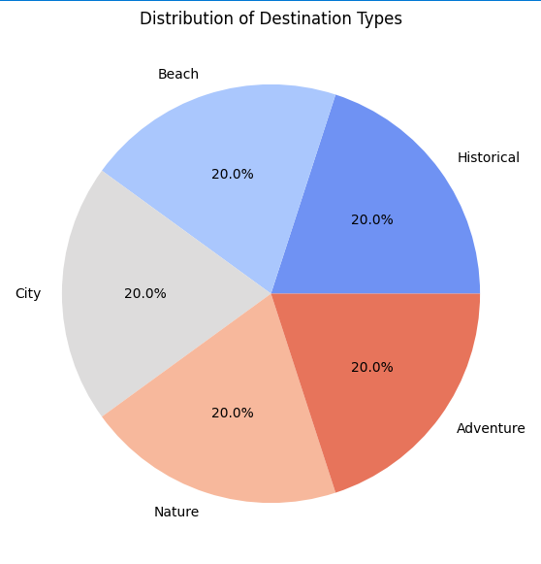  
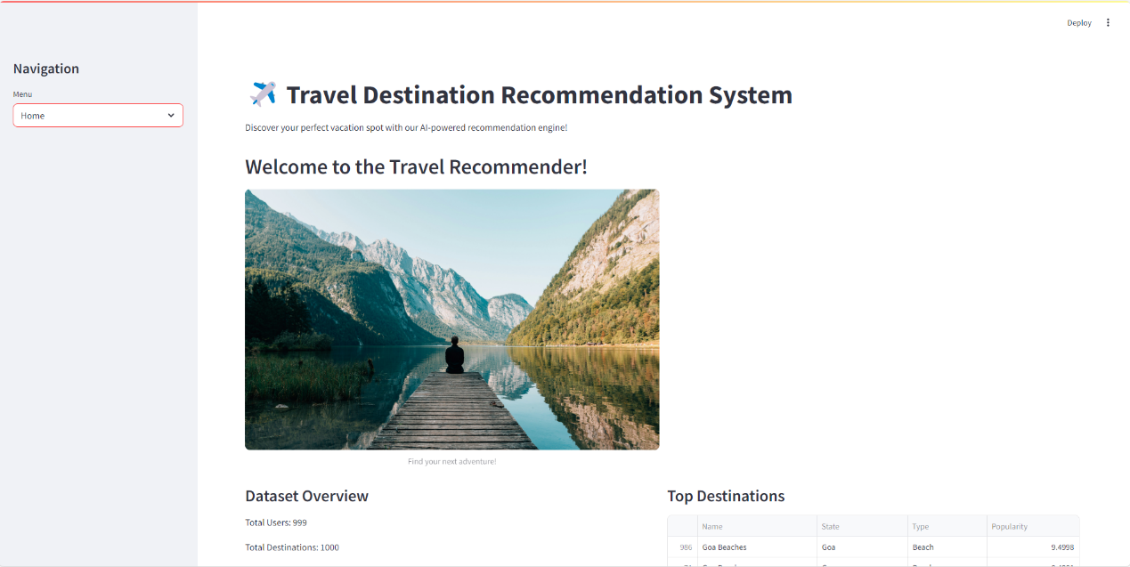

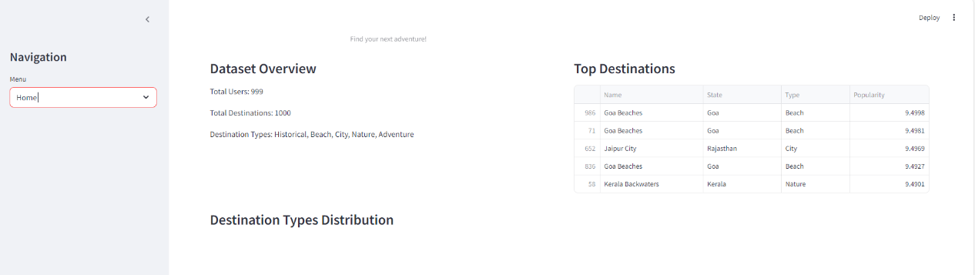

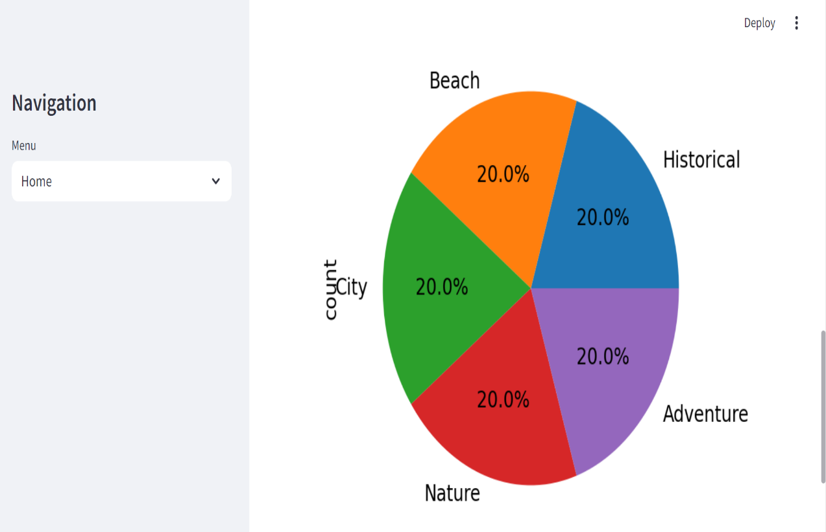

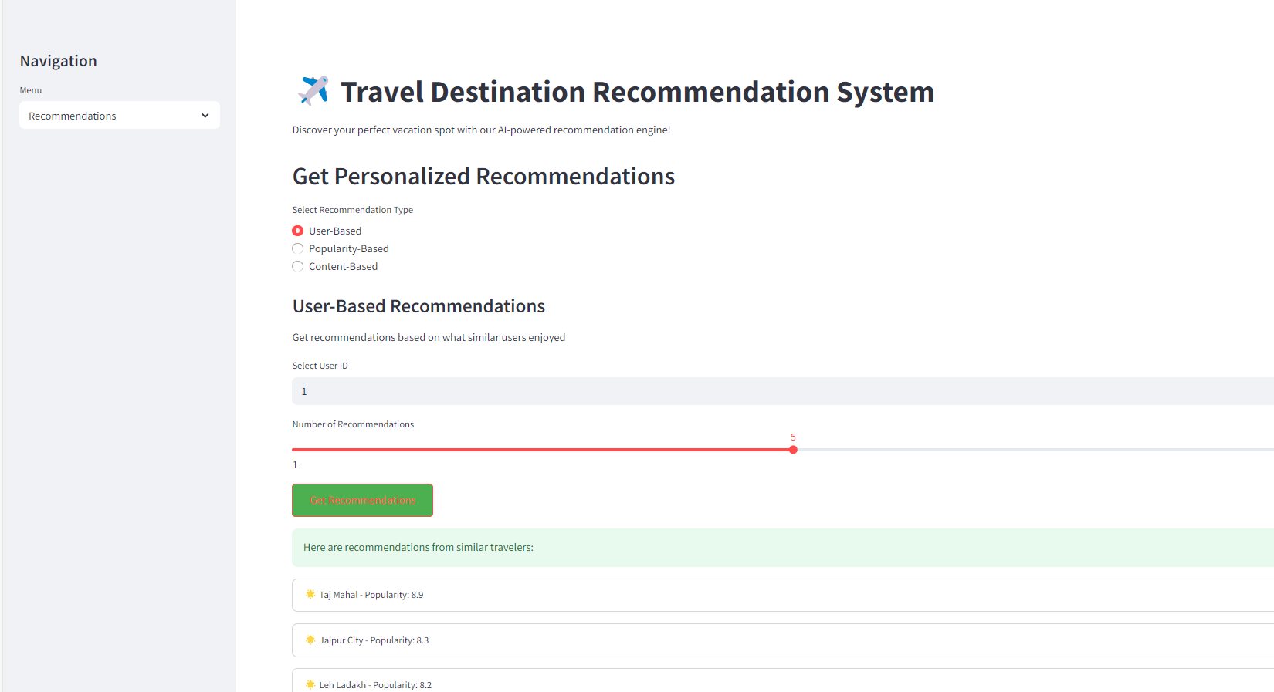

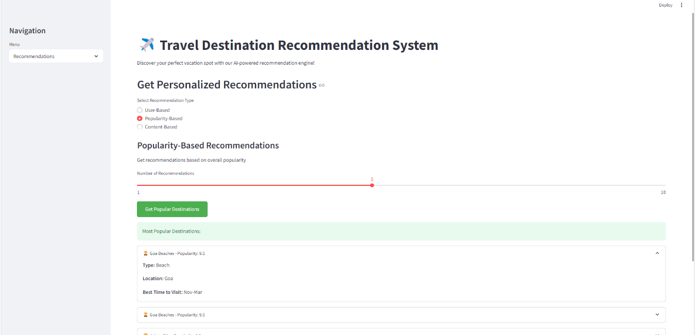

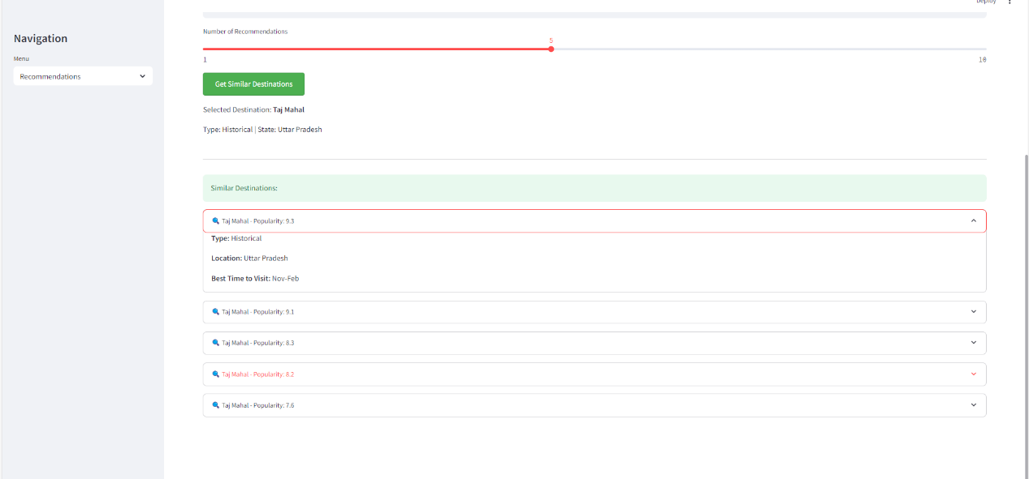

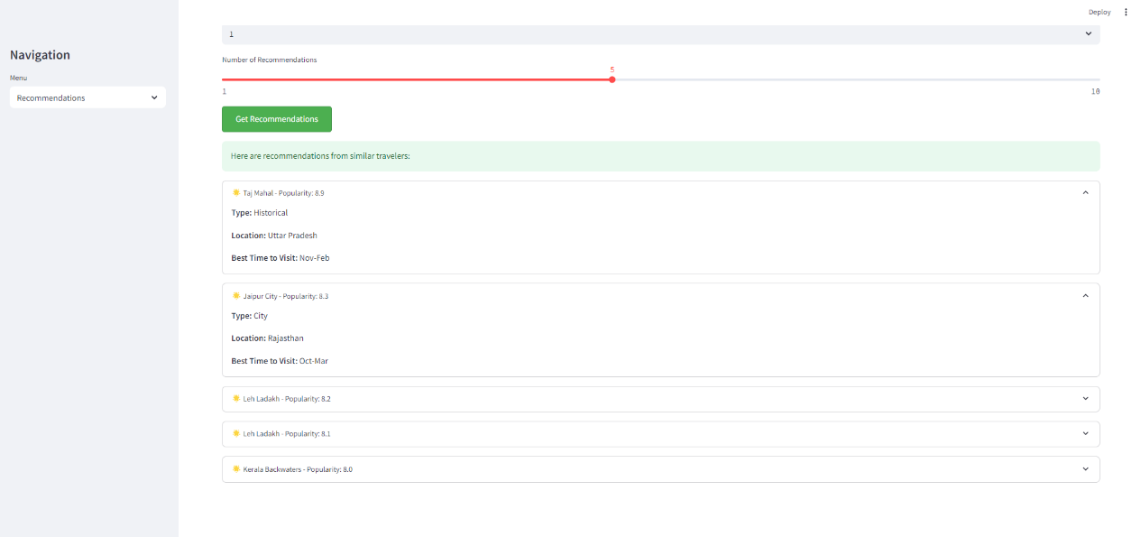

## Advantages and Limitations

Advantages

1. Personalized Travel Suggestions

* Uses AI/ML to analyze user preferences (past trips, budgets, interests) for tailored recommendations.
* Enhances user satisfaction by suggesting relevant destinations, hotels, and activities.

2. Time and Effort Savings

* Automates trip planning by filtering options based on user constraints (budget, dates, preferences).
* Reduces decision fatigue by presenting curated choices.

3. Dynamic and Real-Time Recommendations

* Adapts to real-time factors like weather, flight prices, and local events.
* Recommends last-minute deals or alternative plans in case of disruptions.

4. Improved Travel Experience

* Suggests offbeat destinations and hidden gems based on user behavior.
* Provides multi-modal travel options (flights, trains, road trips) for seamless planning.

5. Business Benefits for Travel Providers

* Increases bookings and customer engagement for hotels, airlines, and tour operators.
* Enables targeted promotions and discounts based on user data.

6. Integration with Social and Crowdsourced Data

* Leverages reviews, ratings, and social media trends for trustworthy suggestions.
* Recommends destinations based on friends’ travel experiences (social travel recommendations).

7. Scalability and Accessibility

* Works across devices (mobile apps, websites, voice assistants).
* Supports multiple languages and currencies for global users**.**

## ****Limitations****

### ****1. Cold Start Problem****

* Struggles to provide accurate recommendations for new users with no prior data.
* Requires initial input or manual preferences to improve suggestions.

### ****2. Data Privacy Concerns****

* Collects sensitive user data (location, spending habits), raising privacy issues.
* Must comply with regulations like GDPR, requiring secure data handling.

### ****3. Over-Reliance on Popularity Bias****

* May favor tourist-heavy destinations, ignoring niche or less-reviewed options.
* Can create overcrowding in recommended spots.

### ****4. Limited Context Understanding****

* AI may misinterpret user intent (e.g., recommending luxury hotels to budget travelers).
* Struggles with complex queries like "romantic yet adventurous destinations."

### ****5. Dependence on Data Quality****

* Inaccurate or outdated information (e.g., closed attractions, wrong pricing) leads to poor recommendations.
* Requires continuous updates from reliable sources.

### ****6. Algorithmic Bias and Lack of Diversity****

* May reinforce stereotypes (e.g., only suggesting "safe" destinations based on demographics).
* Needs fairness-aware AI to ensure inclusive recommendations.

### ****7. High Computational Costs****

* Real-time AI recommendations require significant processing power.
* Scalability challenges for large user bases.

## Conclusion

Travel recommendation systems have revolutionized the way people plan trips by leveraging **AI, machine learning, and big data analytics** to provide personalized, efficient, and dynamic travel suggestions. These systems offer numerous benefits, including **time savings, enhanced user experience, real-time adaptability, and business growth opportunities** for travel providers. By analyzing user preferences, past behavior, and contextual factors, they help travelers discover ideal destinations, accommodations, and activities while simplifying the decision-making process.

However, challenges such as the **cold start problem, data privacy concerns, algorithmic bias, and dependency on high-quality data** remain significant hurdles. Future advancements should focus on:

* **Explainable AI (XAI)** to build user trust through transparent recommendations.
* **Real-time adaptability** to adjust suggestions based on dynamic factors like weather, events, and pricing.
* **Ethical AI and bias mitigation** to ensure fair and inclusive travel recommendations.
* **Hybrid recommendation models** combining collaborative filtering, content-based filtering, and knowledge-based approaches for better accuracy.
* **Privacy-preserving techniques** (e.g., federated learning) to secure user data while maintaining personalization.

As technology evolves, travel recommendation systems will continue to integrate **emerging trends like metaverse-based virtual tours, sustainable travel suggestions, and voice-assisted planning**, further enhancing the travel experience. By addressing current limitations and leveraging new innovations, these systems will play an even more crucial role in shaping the future of smart and seamless travel planning.

## Future Scope

### ****1. Hyper-Personalization with Advanced AI****

* **Generative AI & LLMs:** Integration of models like GPT-4 for natural language-based trip planning (e.g., ChatGPT-powered travel assistants).
* **Behavioral Biometrics:** Analyzing user interactions (clicks, dwell time) for deeper personalization.
* **Emotion-Aware Recommendations:** Sentiment analysis of user reviews/social media to suggest mood-based destinations.

### ****2. Real-Time & Context-Aware Intelligence****

* **IoT & Wearable Integration:** Using smartwatch data (heart rate, stress levels) to recommend relaxing or adventurous activities.
* **Live Crowd & Weather Data:** Dynamic rerouting suggestions to avoid overcrowded spots or bad weather.
* **Event-Driven Recommendations:** Auto-suggesting trips based on concerts, sports events, or festivals.

### ****3. Sustainable & Ethical Tourism****

* **Eco-Friendly Recommendations:** Prioritizing green hotels, carbon-neutral flights, and low-impact destinations.
* **Overtourism Mitigation:** Promoting offbeat locations to reduce pressure on popular spots.
* **Cultural Sensitivity:** Avoiding recommendations that exploit local communities.

### ****4. Metaverse & Virtual Travel****

* **VR Previews:** Allowing users to "experience" destinations virtually before booking.
* **Digital Twin Cities:** AI-powered simulations for personalized virtual tours.
* **NFT-Based Travel Passes:** Blockchain-secured tickets and loyalty programs.

### ****5. Social & Group-Centric Travel****

* **Group Preference Aggregation:** AI mediators to balance preferences for family/friend trips.
* **Social Graph Integration:** Recommendations based on travel histories of trusted networks.
* **Collaborative Trip Planning:** Shared digital itineraries with real-time updates.

### ****6. Autonomous & Multi-Modal Travel****

* **Self-Driving Car Integration:** Recommending optimal routes for autonomous road trips.
* **Seamless Intermodal Journeys:** Combining flights, trains, scooters, and ferries in a single plan.
* **Drone Taxi Compatibility:** Future-proofing for urban air mobility (UAM) networks.

### ****7. Privacy-Preserving Technologies****

* **Federated Learning:** Training AI models on decentralized user data without compromising privacy.
* **Zero-Knowledge Proofs:** Secure age/identity verification for age-restricted destinations.
* **User-Controlled Data Pods:** Letting travelers own and selectively share their data.

### ****8. Voice-First & Ambient Interfaces****

* **Conversational AI:** Voice assistants that plan entire trips via dialogue (e.g., "Plan a surprise anniversary trip to Paris").
* **AR Glasses Integration:** Real-time pop-up recommendations during travels.
* **Auto-Booking Features:** "One-click trip" based on predicted preferences.

### ****9. Predictive & Proactive Systems****

* **Life Event Triggers:** Suggesting honeymoon packages after detecting wedding plans on social media.
* **Health-Based Travel:** Recommending wellness retreats after detecting burnout from work emails.
* **Auto-Rescheduling:** Proactively adjusting itineraries for flight delays or closures.

### ****10. Quantum Computing Applications****

* **Ultra-Fast Optimization:** Solving complex multi-destination routing problems instantly.
* **Hyper-Personalized Pricing:** Real-time dynamic packages based on micro-segmentation

# REFERENCES

1. **Ricci, F., et al. (2011)**  
   "Recommender Systems Handbook" (Chapter 23: Tourism Recommender Systems)
   * Foundational text on hybrid recommendation approaches for travel.
2. **Gavalas, D., et al. (2014)**  
   "Mobile recommender systems in tourism" (Journal of Network and Computer Applications)
   * Covers context-aware mobile tourism recommenders.
3. **Liu, Y., et al. (2021)**  
   "Deep Reinforcement Learning for Travel Recommendation" (IEEE Transactions on Knowledge and Data Engineering)
   * Introduces dynamic adaptation to user preferences.

### ****AI/ML in Travel Recommendations****

1. **Borras, J., et al. (2014)**  
   "Intelligent tourism recommender systems" (Expert Systems with Applications)
   * Compares AI techniques for personalized tourism.
2. **Zheng, V.W., et al. (2017)**  
   "Trajectory-Based Social Recommendation" (ACM Transactions on Intelligent Systems)
   * Uses social media check-ins for recommendations.

### ****Emerging Technologies****

1. **Tussyadiah, I. (2020)**  
   "A review of VR/AR in tourism" (Journal of Hospitality and Tourism Technology)
   * Covers metaverse applications in travel planning.
2. **Nair, B.B., et al. (2022)**  
   "Blockchain for Decentralized Travel Recommendations" (IEEE IoT Journal)
   * Privacy-preserving travel systems using blockchain.